Book Bank Registration System

Class Diagram
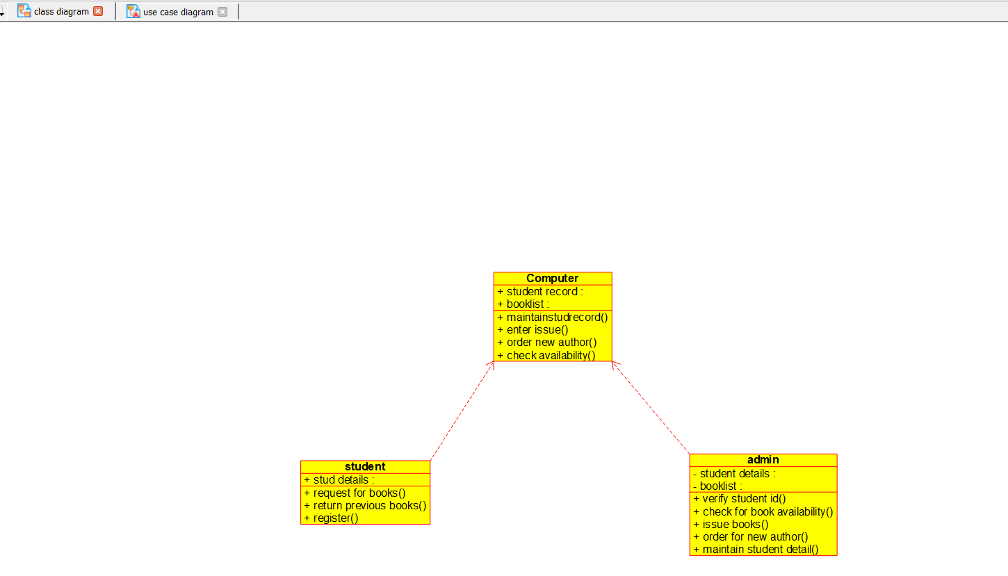
Activity Diagram
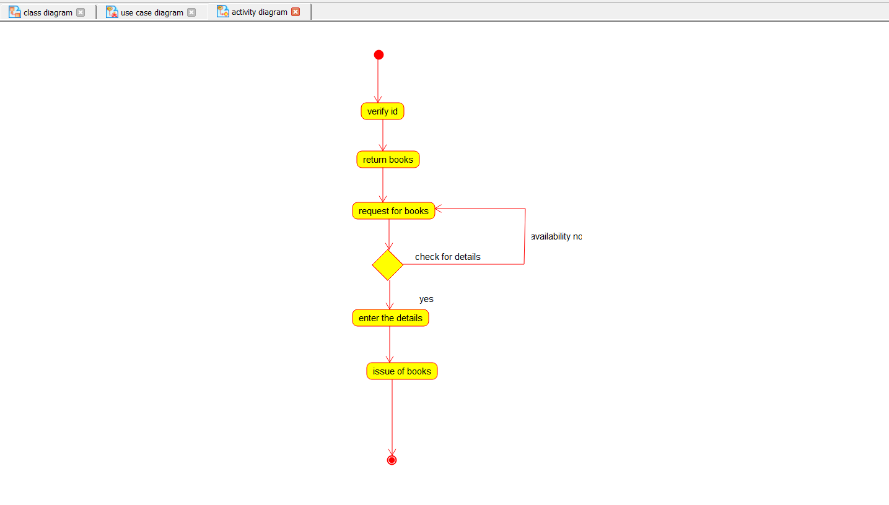

Use Case Diagram
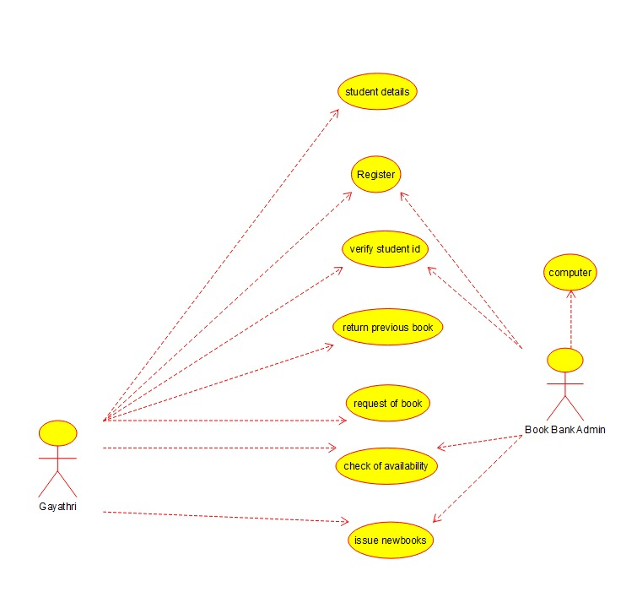
Component Diagram
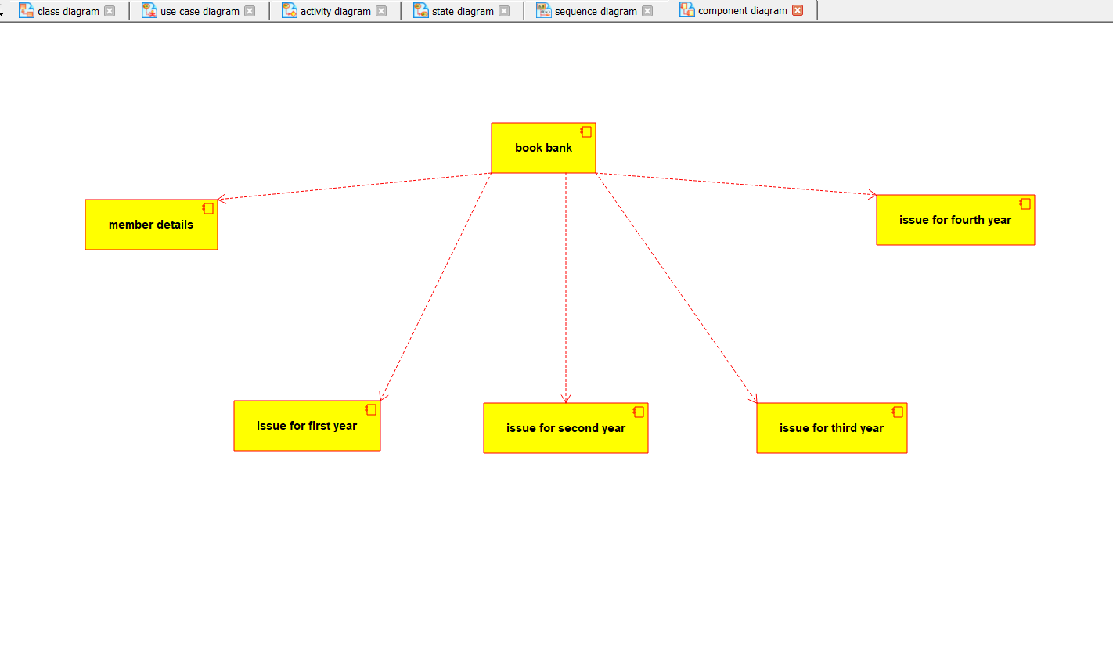

State Diagram
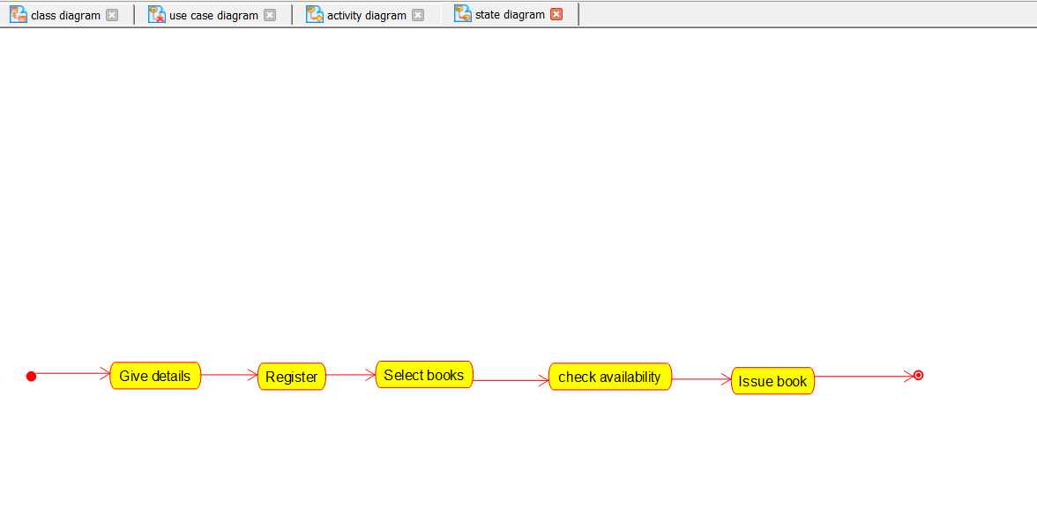
Deployment Diagram
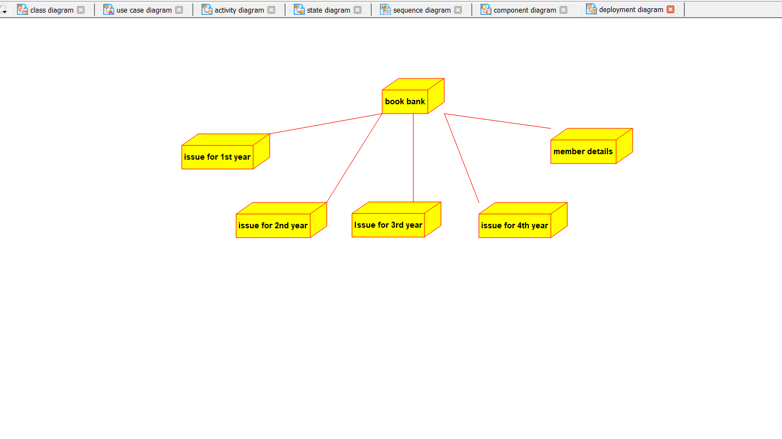

Sequence Diagram
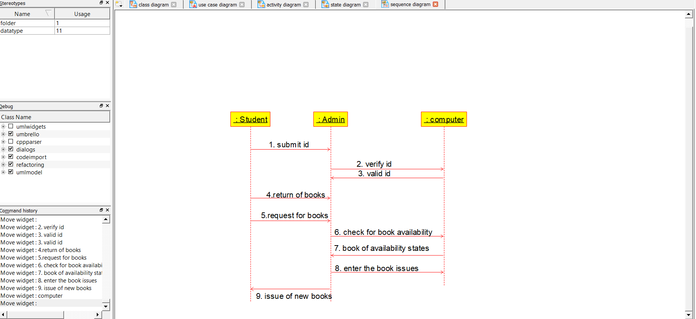

Admin
#include "Admin.h"

// Constructors/Destructors
//

Admin::Admin () {
}

Admin::~Admin () { }

Computer
#include "Computer.h"

// Constructors/Destructors
//

Computer::Computer () {
initAttributes();
}

Computer::~Computer () { }

//
// Methods
//

// Accessor methods
//

// Other methods
//

void Computer::initAttributes () {
}
Student
#include "Student.h"

// Constructors/Destructors
//

Student::Student () {
}
Student::~Student () { }

